**Introduction to Graphs**

Graph is a non linear data structure, it contains a set of points known as nodes (or vertices) and set of linkes known as edges (or Arcs) which connets the vertices. A graph is defined as follows...

Graph is a collection of vertices and arcs which connects vertices in the graph

Graph is a collection of nodes and edges which connects nodes in the graph

Generally, a graph **G** is represented as **G = ( V , E )**, where **V is set of vertices** and **E is set of edges**.

**Example**

The following is a graph with 5 vertices and 6 edges.  
This graph G can be defined as G = ( V , E )  
Where V = {A,B,C,D,E} and E = {(A,B),(A,C)(A,D),(B,D),(C,D),(B,E),(E,D)}.

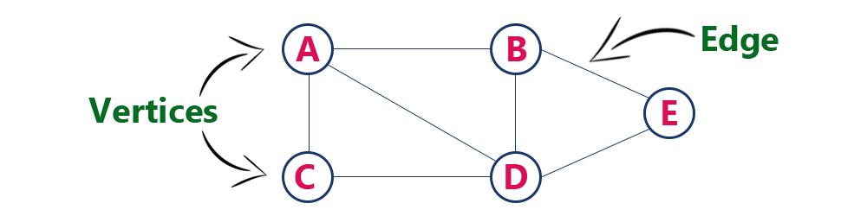

**Graph Terminology**

We use the following terms in graph data structure...

**Vertex**

A individual data element of a graph is called as Vertex. **Vertex** is also known as **node**. In above example graph, A, B, C, D & E are known as vertices.

**Edge**

An edge is a connecting link between two vertices. **Edge** is also known as **Arc**. An edge is represented as (startingVertex, endingVertex). For example, in above graph, the link between vertices A and B is represented as (A,B). In above example graph, there are 7 edges (i.e., (A,B), (A,C), (A,D), (B,D), (B,E), (C,D), (D,E)).  
  
Edges are three types.

1. **Undirected Edge -** An undirected egde is a bidirectional edge. If there is a undirected edge between vertices A and B then edge (A , B) is equal to edge (B , A).
2. **Directed Edge -** A directed egde is a unidirectional edge. If there is a directed edge between vertices A and B then edge (A , B) is not equal to edge (B , A).
3. **Weighted Edge -** A weighted egde is an edge with cost on it.

**Undirected Graph**

A graph with only undirected edges is said to be undirected graph.

**Directed Graph**

A graph with only directed edges is said to be directed graph.

**Mixed Graph**

A graph with undirected and directed edges is said to be mixed graph.

**End vertices or Endpoints**

The two vertices joined by an edge are called the end vertices (or endpoints) of the edge.

**Origin**

If an edge is directed, its first endpoint is said to be origin of it.

**Destination**

If an edge is directed, its first endpoint is said to be origin of it and the other endpoint is said to be the destination of the edge.

**Adjacent**

If there is an edge between vertices A and B then both A and B are said to be adjacent. In other words, Two vertices A and B are said to be adjacent if there is an edge whose end vertices are A and B.